Leasure Elementary

1015 Church Rd

Newark, De 19702

Phone: 302-454-2103

Fax: 302-454-2109

[www.leasurees.org](http://www.leasurees.org)

B.E.A.R.S Club Advisors:

Mr. Timothy Werbrich

Mrs. Nickie Elliott

Mrs. Donna Jeandell

timothy.[werbrich@christina.k12.de.us](mailto:werbricht@christina.k12.de.us)

**B.E.A.R.S. Care Club Recognition**

*2012 & 2016 Governor’s Youth Service Award

* Kids Care Club of the Month (February/March 2012) & January 2014!

* 2012 Jefferson Award for Youth Service

*2013 Jefferson Award Honoree

* “End Childhood Hunger” Grant Recipient 2013 & 14

*Joy Ambassador Grant 2014,15,16

*Over 750 Hours Volunteered in last 2 school years!

Just some of our Projects!

Angel Tree/ Pennies 4 Puppies

Christina River Cleanup

Yarn collection for CareWear

Coastal Cleanup

Food Bank of DE volunteer nights

Thanksgiving Food Drive

Toiletries collection for in need

Hunger To-Go bags

Adopt-A-Highway (Church Rd)

Governor Bacon Nursing Home



# B.E.A.R.S.

# Care Club



**Leasure Elementary**

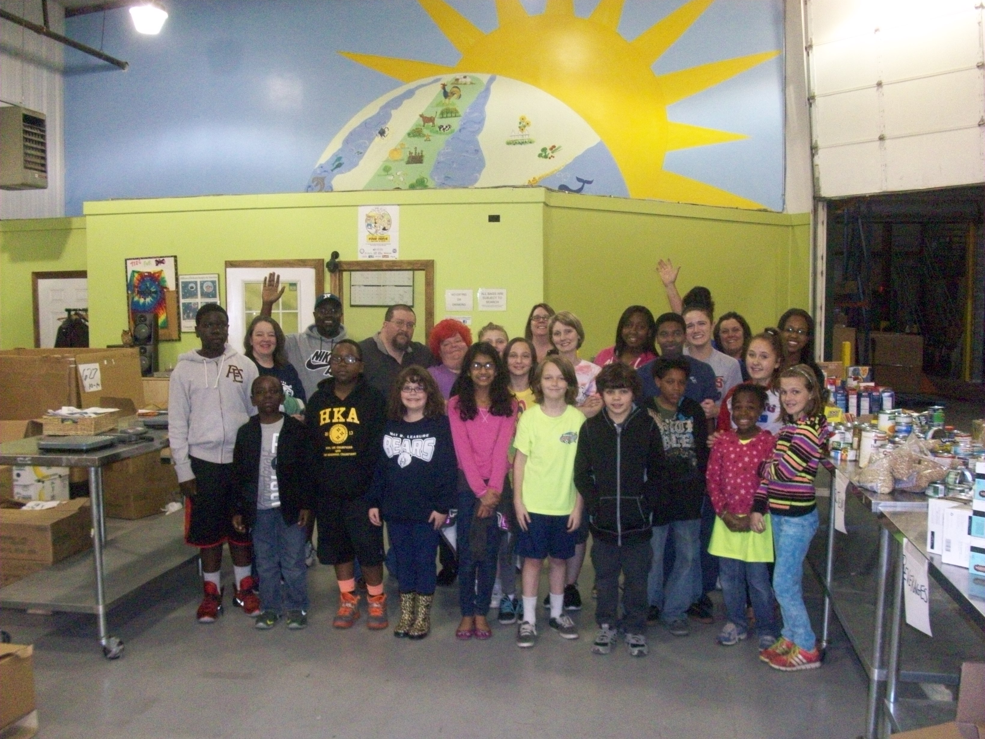

#### Our Past Service Projects

Making Our World a Better Place Through Service.

2015/2016 Governor’s Youth Service Award

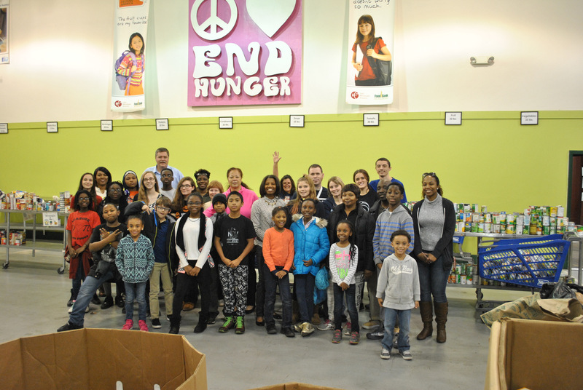

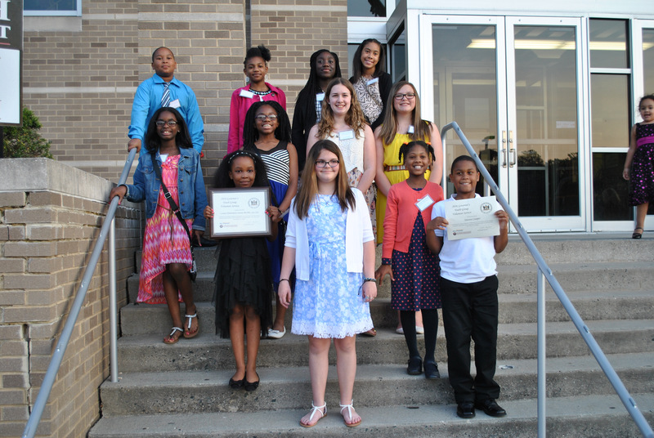

The objectives of Leasure B.E.A.R.S Care Club are:

* To provide opportunities for working together in volunteer service to school and community
* To develop leadership potential
* To foster the development of a strong moral character

# To encourage loyalty to school, community, and nation

Students will be expected to perform at least 15 hours of community service throughout the year. This can be done through school or any other volunteer service away from school.

Students will also need to maintain good academic standing and exhibit model behavior at all times.

# Leasure B.E.A.R.S.

# Care Club

Leasure B.E.A.R.S. Care Club is a student-led service club for Leasure Elementary students.

**B.E.A.R.S.** stands for:

**B**uilding

**E**mpowerment,

**A**wareness, &

**R**esponsibility through

**S**ervice.

Service hours will be documented and kept for each student participating in the B.E.A.R.S Club.

An appreciation/awards celebration will be held at the end of the school year for those students who complete at least 20 hours of volunteer service. A cool t-shirt will be given for those doing only 10 hours of service. Students may also be eligible for The Presidential and Governor’s Awards for Service.

Food Bank of Delaware Volunteer Night

#### Leasure B.E.A.R.S. Care